Search Results Page
Directions: Circle and label the following parts on this search results page:
(1) search bar
(2) advertisements
(3) natural results
(4) filters
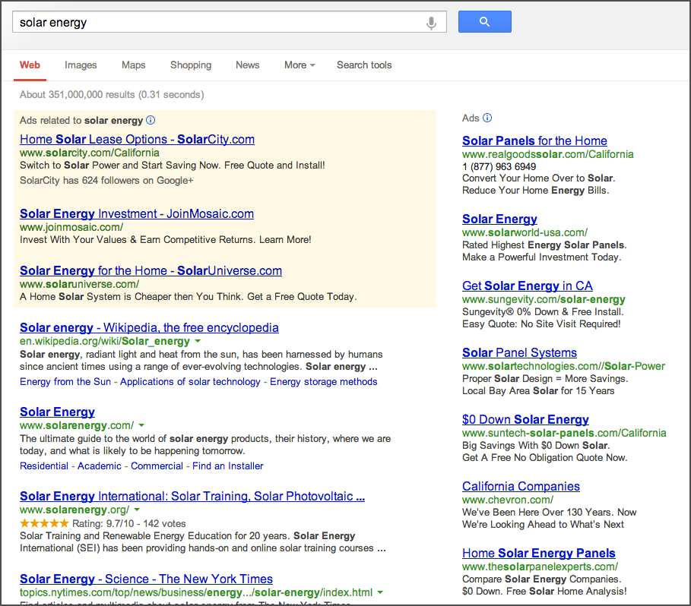What Might You Find in These Web Addresses?
Web Address | What might you find at each address?
www.math-play.com/Integers-Jeopardy/Integers-Jeopardy.html
www.bl.uk/onlinegallery/features/americanrevolution/index.html
www.sjusd.org/leland/teachers/sgillis/mapping/hist_of_maps3.ppt
wiki.answers.com/Q/Where_was_George_Washington_born

